|  |
| --- |
| Angela Andrews Ryan  2025 Scholarship  Grand Rapids Sister Cities International | Perugia, Italy | Università per Stranieri  **Application Deadline: April 15, 2025** |

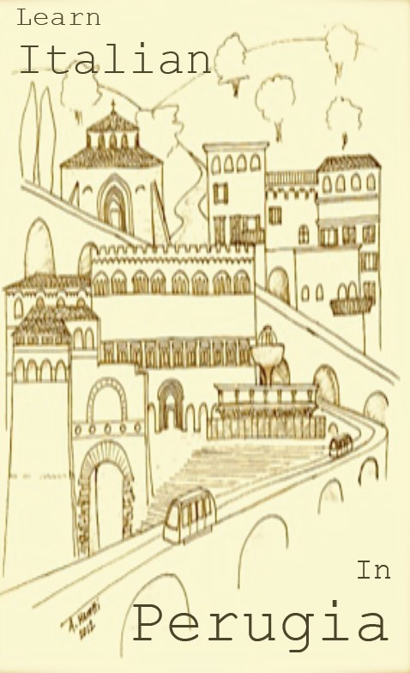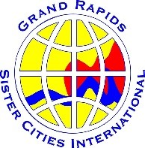Founded by the Grand Rapids Sister

Cities International Perugia

Committee, in partnership with the University for Foreigners (UNISTRA) in Perugia, this program has awarded scholarships to over 50 recipients in the last 25 years.

**Beneficiaries spend one month immersed in the history and culture of our sister city, Perugia, studying the Italian language.**

**The Scholarship Award includes**:

* A one-month, tuition-free Italian course at the University for Foreigners
* A modest living stipend offered by UNISTRA
* A $600 cash award from the GRSCI Perugia Committee to assist with travel expenses to/from Perugia.

See application details on the next page or visit www.grsistercities.org.   
  
Grand Rapids Sister Cities International (GRSCI) is a non-profit organization that works to build relationships between Grand Rapids and its sister cities by promoting understanding and mutual respect through exchanges in culture, art, community, and economic development.

How to Apply for the  
GRSCI Perugia Committee  
Angela Andrews Ryan Scholarship 2025

Applicant Requirements:

1. Must be a Grand Rapids resident or a student attending a Grand Rapids area college or university
2. Submit the following items:
   1. A completed application
   2. A resume with cover letter
   3. Two letters of recommendation
3. Upon return from Perugia, scholarship recipients are required to write a report to the Perugia Sister City Committee.

The current deadline for submissions is **April 15, 2025**.

The classes start at the beginning of each month and last four weeks. The winner of the 2025 scholarship can travel to Perugia in any remaining 2025 month they choose*, once notified they have been selected.

We request that the non-student recipients participate with the Perugia Sister City committee by attending monthly meetings for at least one year and that they agree to volunteer, if needed, for at least two events during the year after their stay.

Please e-mail grsistercities.perugia@gmail.com with any questions or for additional information about the scholarship program.

**Recipients of the scholarship have described the experience as “life changing.” It has offered them the opportunity not only to immerse themselves in Italian language, history, and lifestyle; but also to travel around Italy and network with other language students from around the world.**

*Provided ample time to enroll in class is provided.

**Perugia Sister City**

**Angela Andrews Ryan Scholarship**

**2025 Application**

## Contact Information

First Name Last Name

Home Address

City State Zip

Phone Email

## If a Student Applicant

College Academic Year

Major(s) Minor(s)

## If an Adult Applicant

Current Employer Job Title

## Recipient Criteria

* Upstanding individual: will represent the Perugia Committee and City of Grand Rapids in an upstanding and reputable manner.
* Independence, self-sufficiency, adaptability: has previous travel experience OR can establish examples of independent living/activity
* Has established history/past in effort of learning the Italian language, or other foreign language.
* Demonstrate this experience will have an impact on your future goals/plans

## Application Materials

* Application form
* Resume/CV
* Two letters of recommendation
* Cover letter addressing the following questions, keeping the above criteria in mind (1,000 words max)
* What inspires you to study abroad in Italy and study Italian language and culture?
* In what ways do you see yourself contributing to awareness of the sister cities relationship, both while in Perugia and after you return home?

**Email all application materials to grsistercities.perugia@gmail.com by April 15, 2025** For questions about the scholarship or application process, please email us.